**Lab 9**

**Name:** Trần Gia Khôi

**ID:** ITITIU21231

**Exercise 1: Project Setup & User Entity**

**Task 1.1: Add Security Dependencies**

Spring Security dependency added

JWT dependencies added correctly

Maven dependencies resolve

**Task 1.2: Create User Entity and Role Enum**

Role enum created

Entity annotations correct

Lifecycle callbacks implemented

Getters/setters complete

**Task 1.3: Database Setup**

User table created

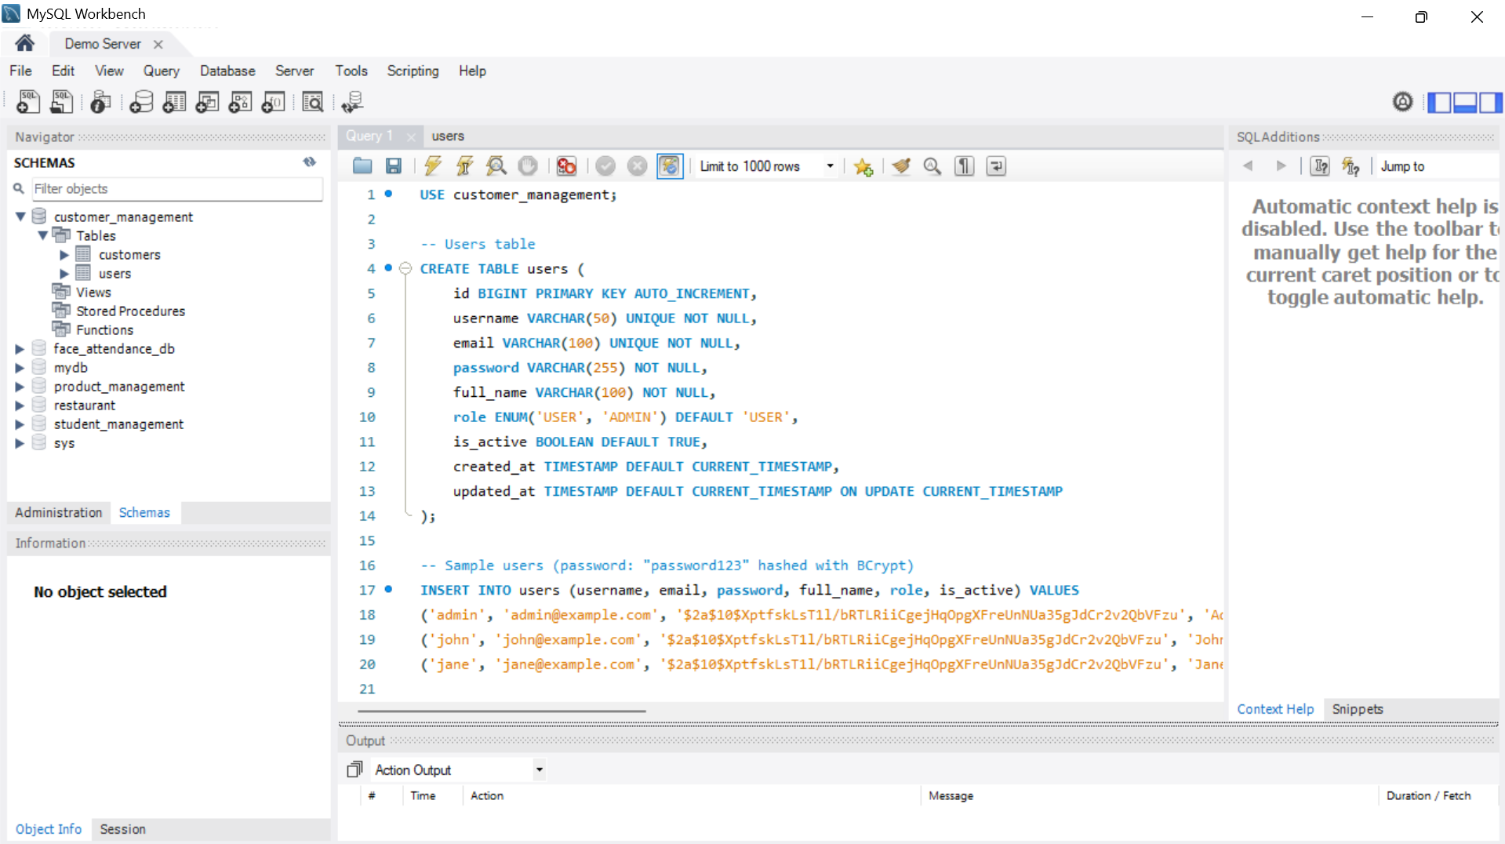

Sample users inserted

JWT config added

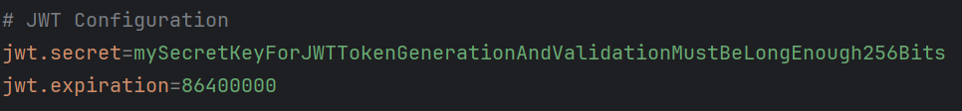

**Exercise 2: DTO & Repository**

**Task 2.1: Create Authentication DTOs**

LoginRequestDTO with validation

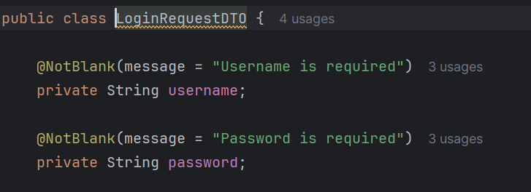

LoginResponseDTO complete

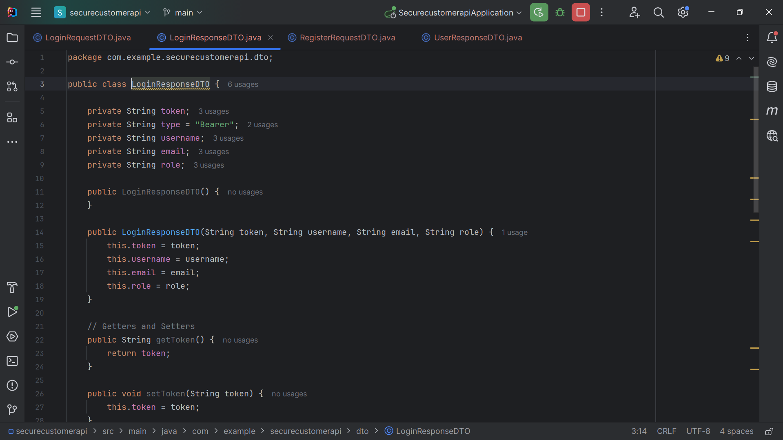

RegisterRequestDTO with validation

UserResponseDTO complete

**Task 2.2: Create User Repository**

Repository extends JpaRepository



Custom query methods defined

**Exercise 3: JWT & Security Components**

**Task 3.1: Create JWT Token Provider**

generateToken() implemented

getUsernameFromToken() implemented

validateToken() implemented

**Task 3.2: Create JWT Authentication Filter**

Filter extends OncePerRequestFilter

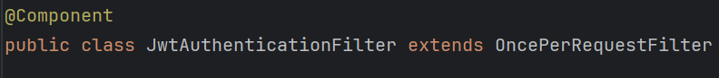

JWT extraction from header



Token validation logic

Authentication set in SecurityContext



**Task 3.3: Create Custom UserDetailsService**

Implements UserDetailsService



loadUserByUsername() implemented

Authorities conversion correct

**Exercise 4: Security Configuration**

**Task 4.1: Create Security Config**

PasswordEncoder bean created

AuthenticationManager configured

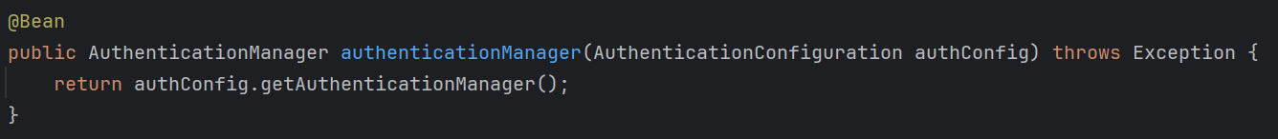

SecurityFilterChain configured



Endpoint security rules correct

JWT filter added correctly



**Task 4.2: Create Authentication Entry Point**

Implements AuthenticationEntryPoint

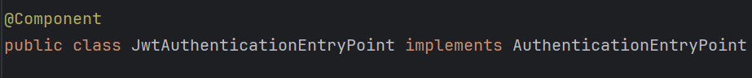

Returns proper 401 JSON response

**Exercise 5: User Service & Auth Controller**

**Task 5.1: Implement User Service**

UserService created



Custom methods in UserService

Implementation of custom methods

login()

register()

getCurrentUser()

**Task 5.2: Create Auth Controller**

Create endpoints

POST /api/auth/login

POST /api/auth/register

GET /api/auth/me

POST /api/auth/logout

**Task 5.3: Update Customer Controller**

Add @PreAuthorize annotations:

**Workflow:**

**1. Registration**

Client → POST /api/auth/register {username, email, password}

Server → Hash password with BCrypt

Server → Save user to database

Server → Return: 201 Created

**2. Login**

Client → POST /api/auth/login {username, password}

Server → Verify username exists

Server → Compare password with hashed password

Server → Generate JWT token with username, role, expiry

Server → Return: {token: "eyJhbG...", username, email, role}

Client → Store token in localStorage

**3. Accessing protected endpoints**

Client → GET /api/customers

Header: Authorization: Bearer eyJhbG...

Server → JwtAuthenticationFilter intercepts request

Server → Extract token from Authorization header

Server → Validate token (signature, expiry)

Server → Extract username from token

Server → Load user details from database

Server → Set authentication in SecurityContext

Server → Process request Server → Return response

